SQL MODULE LB – 3

**By**

Pedda Jagadeesh

Questions

Task 1: Update the Student table with the following information:

Change the email to 'jane_Smith@example.com'

Where FirstName is 'Jane' and LastName is 'Smith';

Update the Instructor with the following information:

Change the email to 'rogerwhite@example.com'

Where FirstName of the instructor is 'Roger' and LastName is 'White';

Task 2:

Delete the record from the Student table on the following condition:

Delete student/students records from the Student table where last name is Smith.

Task 3: List the student whose first name starts with J.

Submission: Create an SQL script file containing your solutions for all tasks

(queries). Name the file "lab_assignment1.sql" Provide comments above each

query to indicate the task number and the query's purpose.

Lab 2. Database Schema:

Consider a simple database with one tables: Employee

Employee Table:

● Columns: emp_id (Primary Key), first_name, last_name, age, email

Task 1: Insert Data

Write an SQL INSERT statement to insert data into the Employee table.

Task 2: Retrieving Data

Write an SQL SELECT statement to retrieve the first_name and last_name of all

employees from the Employee table.

Task 3: Filtering Data

Write an SQL SELECT statement to retrieve the first_name, last_name, and age of

employees who are older than 30 years.

Task 4: Updating Data

Write an SQL UPDATE statement to increase the age of employees by 1 year for all

employees older than 25.

Submission:

Create an SQL script file containing your solutions for all tasks (queries). Name the

file "lab_assignment2.sql" Provide comments above each query to indicate the

task number and the query's purpose.

ChatGPT Exercise

Using ChatGPT generates SQL queries to update the Employee salary.

Scenario:

Due to a pricing adjustment, the company decided to increase the salary of all

employees by 10%. Create an SQL update query to apply this change selectively to

employees with a specific job title, say 'Manager'

Solutions:

Task 1: Update the Student table with the following information:

Change the email to 'jane_Smith@example.com'

Where FirstName is 'Jane' and LastName is 'Smith';

Update the Instructor with the following information:

Change the email to 'rogerwhite@example.com'

Where FirstName of the instructor is 'Roger' and LastName is 'White';

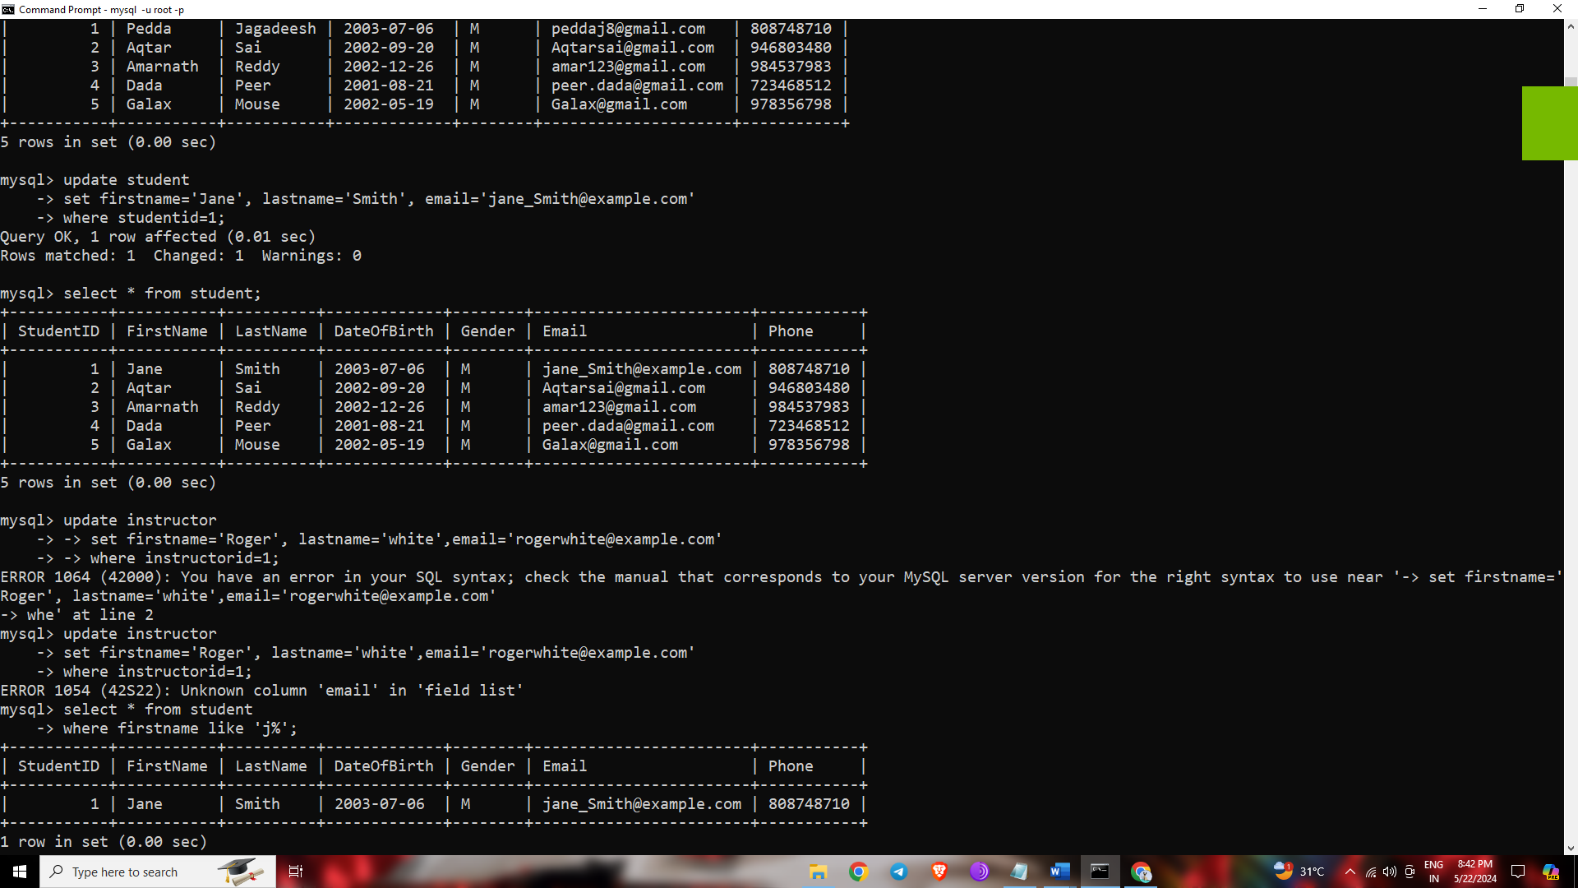

Instructor table:

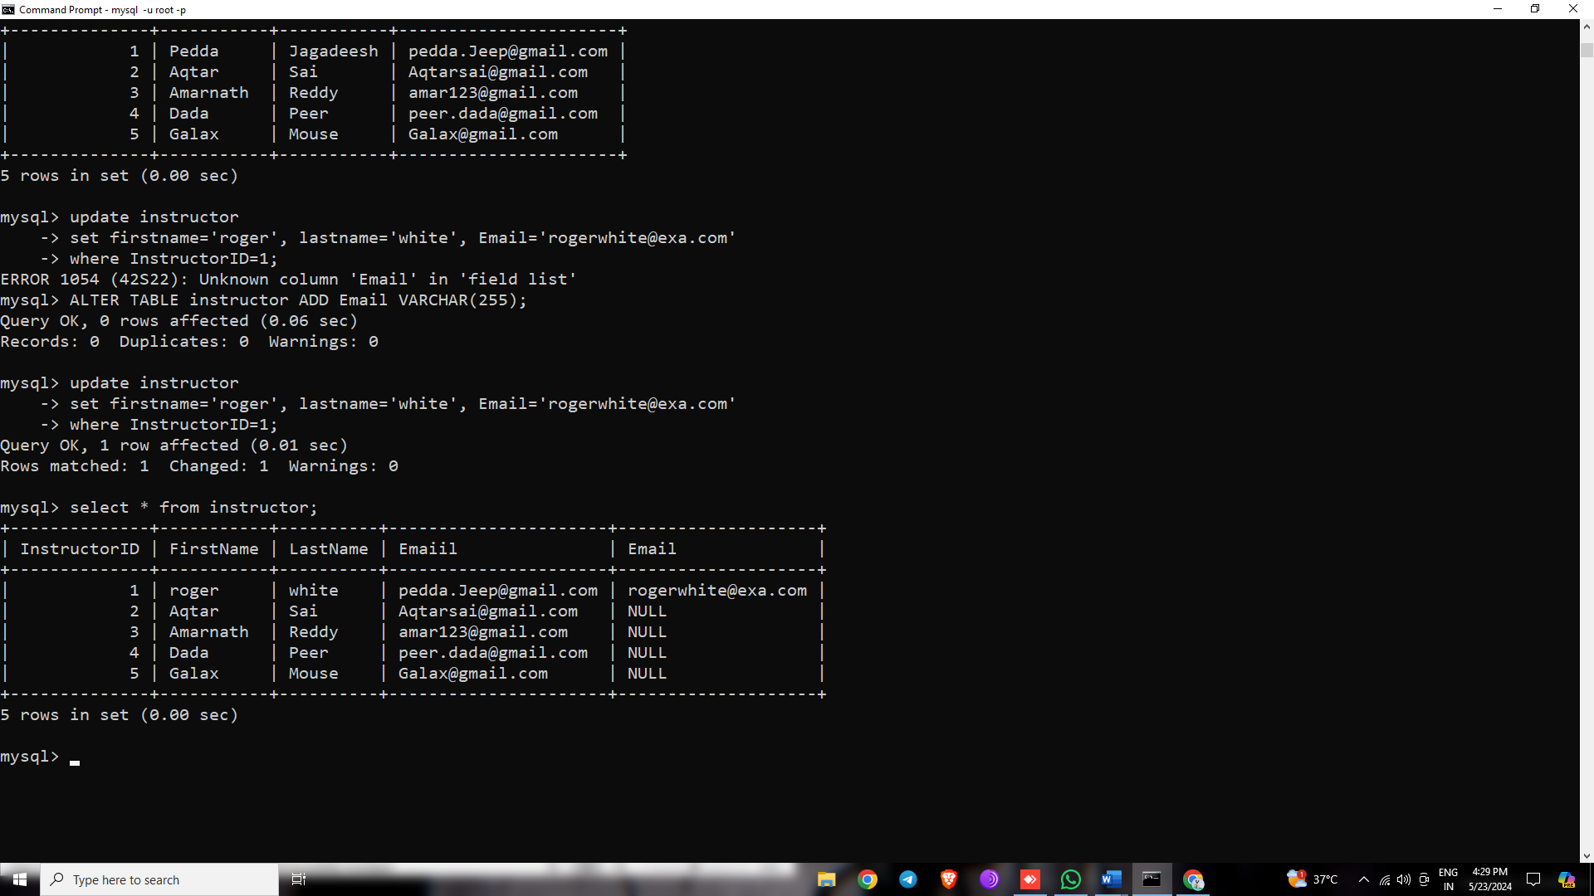



Task2: Delete record from the Student table on following condition:

Delete student/students records from the Student table where last name is Smith.

: List the student whose first name starts with J.

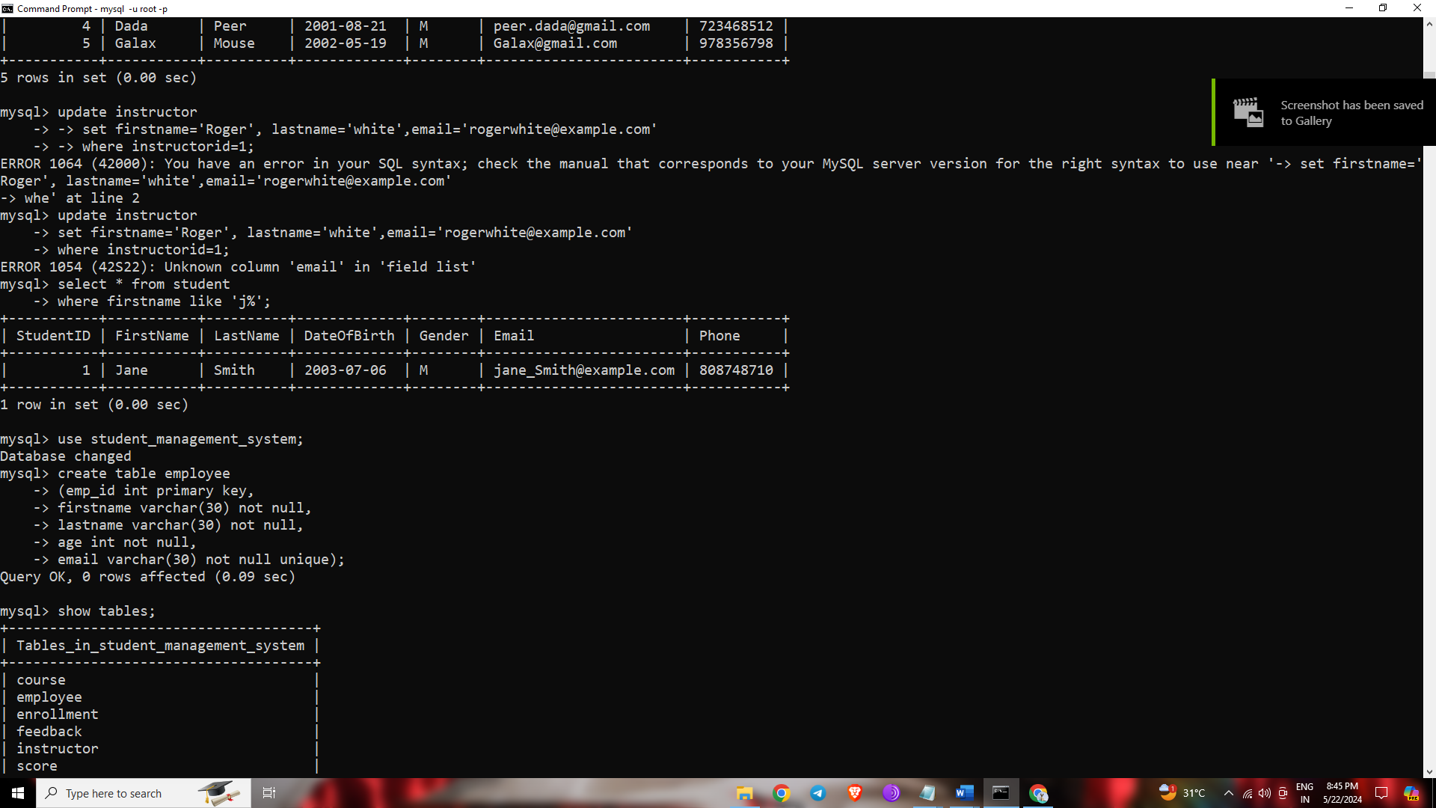

Lab 2. Database Schema:

Consider a simple database with one tables: Employee

Employee Table:

● Columns: emp_id (Primary Key), first_name, last_name, age, email

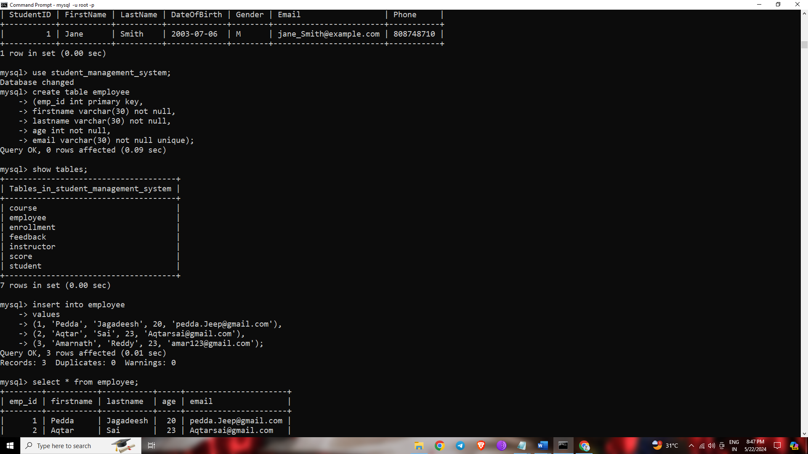

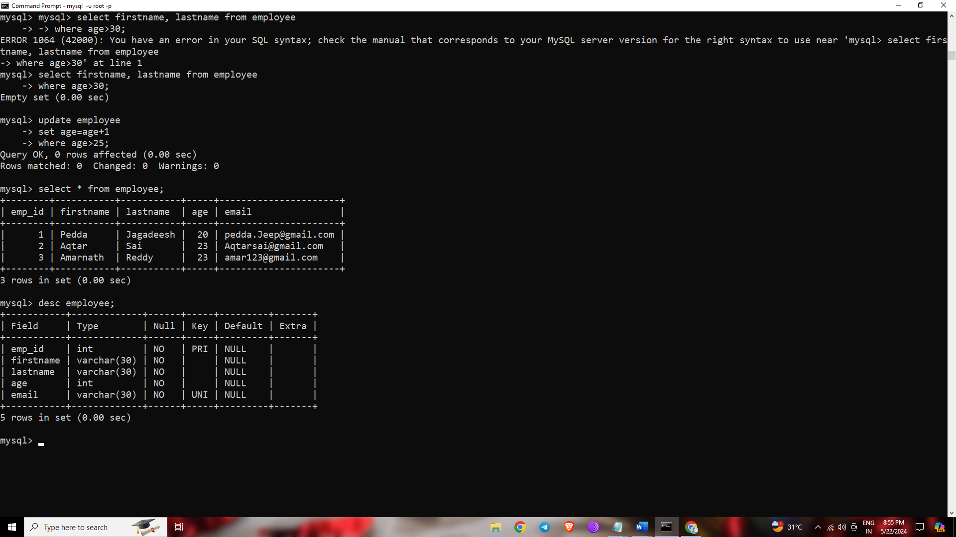

Task 1: Insert Data

Write an SQL INSERT statement to insert data into the Employee table.

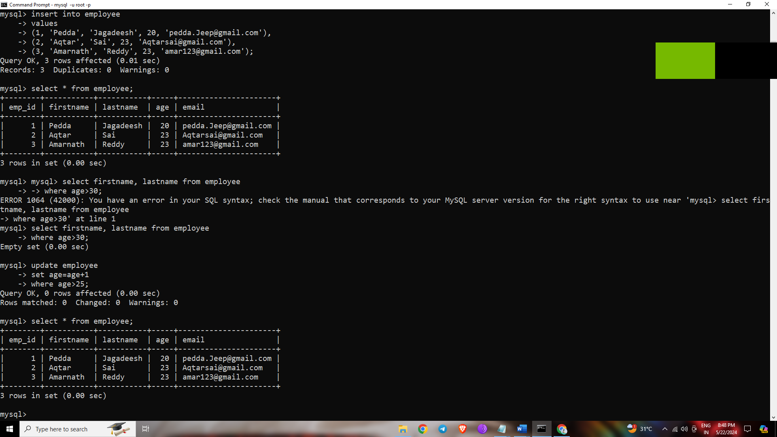

Task 2: Retrieving Data

Write an SQL SELECT statement to retrieve the first_name and last_name of all

employees from the Employee table.



Task 3: Filtering Data

Write an SQL SELECT statement to retrieve the first_name, last_name, and age of

employees who are older than 30 years.

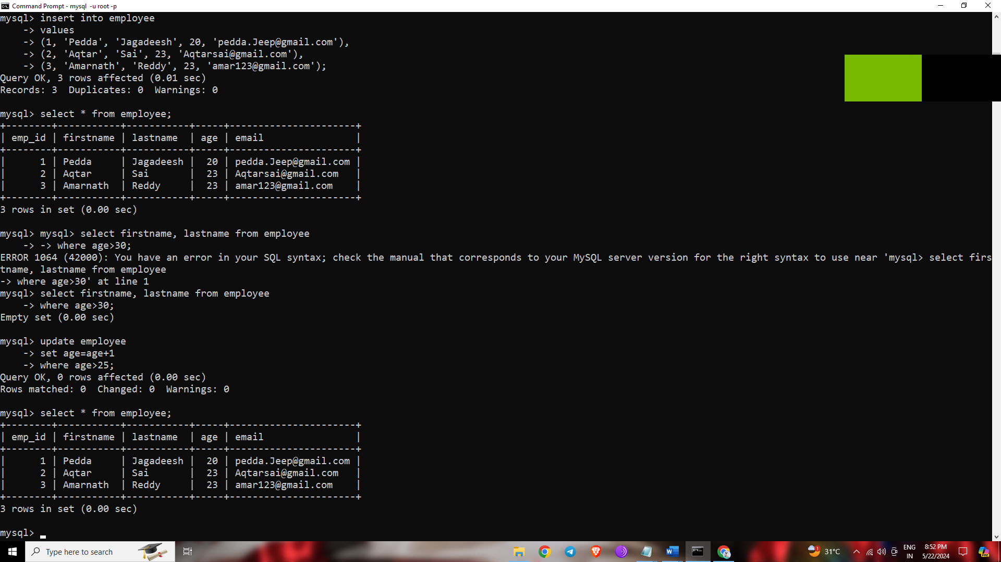

Updating Data

Write an SQL UPDATE statement to increase the age of employees by 1 year for all

employees older than 25.



ChatGPT Exercise

Using ChatGPT generates SQL queries to update the Employee salary.

Scenario:

Due to a pricing adjustment, the company decided to increase the salary of all

employees by 10%. Create an SQL update query to apply this change selectively to

employees with a specific job title, say 'Manager'

sol:-

To selectively update the salary of all employees with the job title 'Manager' by 10%, you can use the following SQL `UPDATE` statement:

```SQL

UPDATE employees

SET salary = salary * 1.10

WHERE job_title = 'Manager';

```

### Explanation:

1. **UPDATE employees**: This specifies the table that you want to update.

2. **SET salary = salary * 1.10**: This updates the `salary` column by increasing its value by 10%.

3. **WHERE job_title = 'Manager'**: This condition ensures that only the rows where the `job_title` is 'Manager' are updated.

Make sure to run this query in a transaction or test environment first to ensure it behaves as expected.

Conclusion:

In conclusion, creating a normalized database for emergency contact information involves structuring the data into related tables to minimize redundancy and maintain data integrity. By separating data into Individuals, Contacts, and Addresses tables, we ensure each piece of information is stored efficiently and can be easily maintained.

Additionally, to address specific business requirements, such as updating employee salaries selectively, we can use precise SQL queries. For example, increasing the salary of all employees with the job title 'Manager' by 10% can be achieved with a targeted UPDATE statement, ensuring that only the relevant records are modified.

By following these best practices in database normalization and SQL query formulation, we can create robust, maintainable, and scalable database systems